# 1. INTRODUCTION

## 1.1 Project Overview:

When it comes to tracking expenses, you can make your system as simple as collecting receipts and organizing them once a month.You might get a little more information from other expense tracking systems (listing them in a spreadsheet, using money management software or even choosing an online application), but all methods have one thing in common: you have to get in the habit of thinking about your expenses. It’s very easy to misplace a receipt or forget about any cash you spent. You may even think that a cup of coffee or a trip to the vending machine isn’t worth tracking — although those little expenses can add up amazingly fast. There are all sorts of opportunities to throw a kick into your plan to track expenses. You have to get in the habit of doing so, to reduce those lapses, and make sure that the data you’re basing financial decisions on is solid. This project will request the clients to add their expenses and in view of their costs, wallet status will be refreshed which will be noticeable to the client.

## 1.2 Purpose:

Personal finance management is an important part of people’s lives. However, everyone does not have the knowledge or time to manage their finances in a proper manner. And, even if a person has time and knowledge, they do not bother with tracking their expenses as they find it tedious and time-consuming. Now, you don’t have to worry about managing your expenses, as you can get access to an expense tracker that will help in the active management of your finances.

Also known as expense manager and money manager, an expense tracker is a software or application that helps to keep an accurate record of your money inflow and outflow. Many people in India live on a fixed income, and they find that towards the end of the month they don’t have sufficient money to meet their needs. While this problem can arise due to low salary, invariably it is due to poor money management skills.

People tend to overspend without realizing and this can prove to be disastrous. Using a daily expense manager can help you keep track of how much you spend every day and on what. At the end of the month, you will have a clear picture where your money is going. This is one of the best ways to get your expenses under control and bring some semblance of order to your finances.

# 2. LITERATURE SURVEY

## 2.1 Existing Problem:

* Lack of visual analytics for visual data.
* Lack of support for splitting up group expenses.
* Most of the applications are used only for personal use.
* Most of the applications does not incorporate shared group expenses.
* Efforts has to be made to include each and every transaction into the input field.
* Manual entry and routing of expense reports.
* Lack of visibility into spend data.

## 2.2 References:

* **SPENDING TRACKER: A Smart Approach to Track Daily Expenses**

**Authors**: UP Singh, AK Gupta, Dr. B. Balamurugan

**Description**:  
In this paper, a Java GUI based application was proposed to assure that it will Help its users to manage the cost of their daily expenditure. It will guide them and aware them of their daily expenses. The proposed design contained the basic modules for Adding and viewing expenses, managing expense categories. Supports CRUD Operations on expense data.

**Year**: 2021

**Technologies**: Java

* **EXPENSE TRACKER APPLICATION**

**Authors**: Velmurugan.R , Mrs.P.Usha

**Description**:

This is an android based application that allows users to maintain a computerized Diary to track expenses on a day-to-day basis to stay on budget and know expenses That are represented via a graphical representation with special features of distributing Expenses in different categories suitable for the user.

**Year**: 2021

**Technologies**: Java, XML, and MySQL

* **STUDENT EXPENSE TRACKING APPLICATION**

**Authors**: Saumya Dubey , Pragya Dubey , Rigved Rishabh Kumar , Aaisha Khatoon

**Description**:

This is an android application which is used to track the daily expenses of a student.. The Application keeps track of money spent and the earnings of both of the students on a Day-to-day basis. It also has the feature that it gives warning messages if we are Exceeding our expenses and hence, we can limit our expenses and avoid Overspending. If you spend less money than the daily expense allowed amount, the Money left after spending is added into the user’s savings.

**Year**: 2022

**Technologies**: Java

* **EXPENSE TRACKER USING STATISTICAL ANALYSIS**

**Authors:** Muskaan Sharma, Ayush Bansal, Dr. Raju Ranjan, Shivam Sethi

**Description:**

In this paper, an approach has been proposed on how to efficiently manage house-old budget. This application will allow users to keep track of their expenses. This novel expense tracker uses statistical analysis which is going to keep a track of your expenses and would even give you results accordingly.

**Year:** 2021

**Technologies:** Java

* **BUDGET ESTIMATOR ANDROID APPLICATION**

**Authors:** Namita Jagtap, Priyanka Joshi, Aditya Kamble

**Description:**

The system known as Budget Estimator is designed to manage the application user ‘s daily expenses in a more efficient and manageable way. This project is about mobile application Expenses system with geo-location tracking, based on the location of the user, it using Google Places, to check, the available store in the area, provides a notification for offers purpose, in term of security design, this system may implement a login authentication such as OTP message to your mobile device, this function may bring more security confidence to user. To reduce manual calculations, we propose an application which is developed by android. This application allows users to maintain a digital automated diary.

**Year:** 2021

**Technologies:** Java

* **SAWANT-EXPENSE TRACKER**

**Authors**: Atiya Kazi, Praphulla S. Kherade , Raj S. Vilankar , Parag M

**Description:**

In this approach, the application keeps track of the Income and Expenses of both users on a day-to-day basis. This application takes the income of a user and manages its daily expenses so that the user can save money. If you exceed the daily expense allowed amount it will give you a warning, so that you don’t spend much and that specific day. If you spend less money than the daily expense allowed amount, the money left after spending is added into the user's savings. The application generates report of the expenses of each end of the month

**Year:** 2021

**Technologies:** Java

## 2.3 Problem Statement:

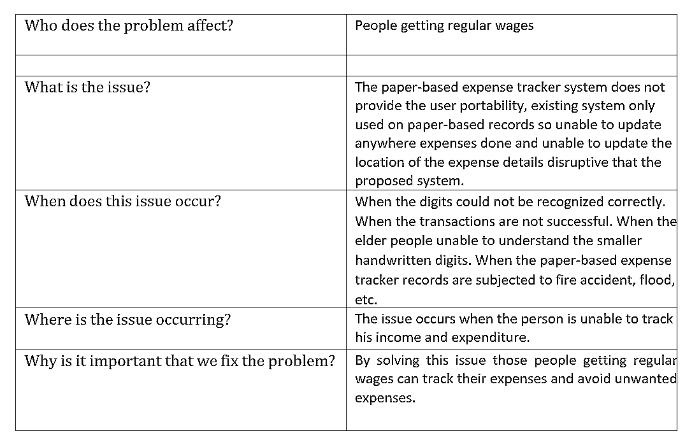

# 3. IDEATION & PROPOSED SOLUTION

## 3.1 Empathy Map Canvas:

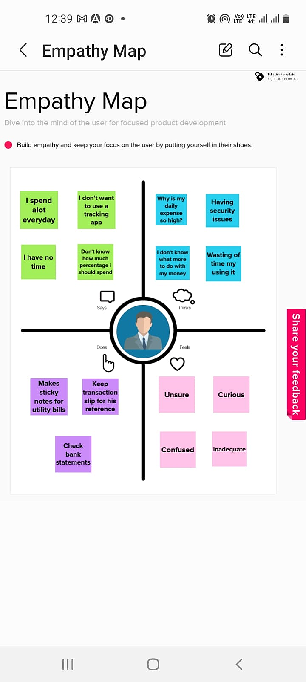

## 3.2 Ideation & Brainstorming:

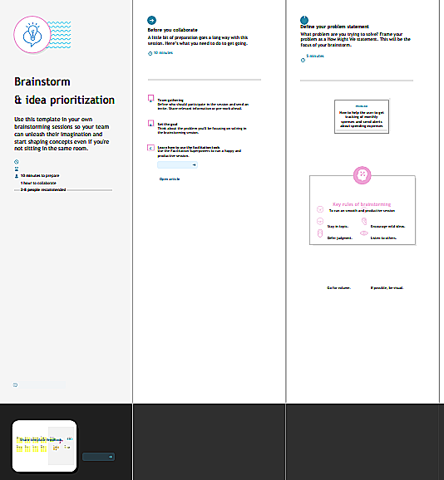 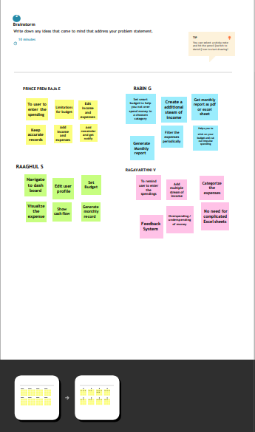

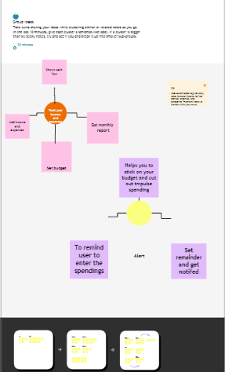 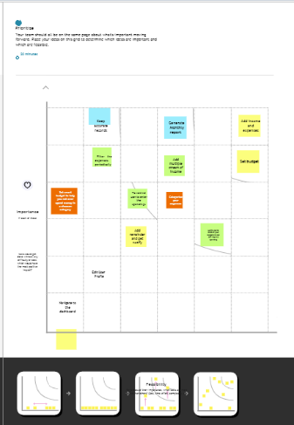

## 3.3 Proposed Solution:

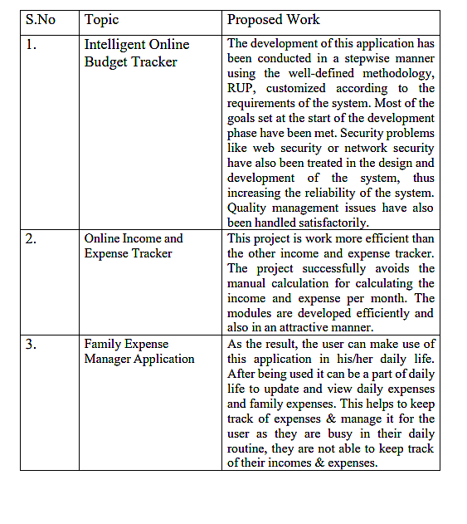

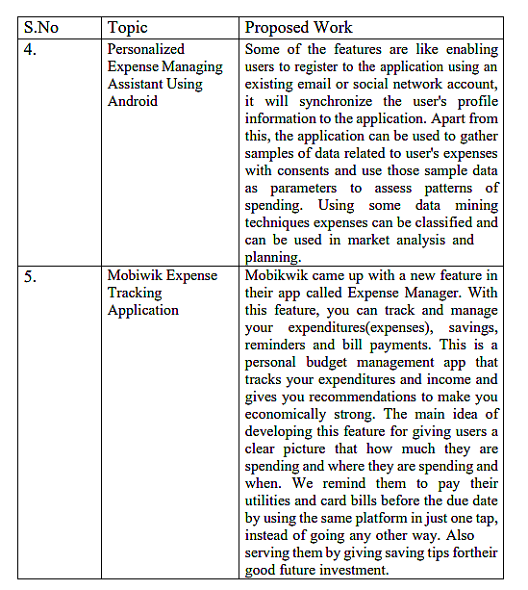

## 3.4 Problem Solution Fit:

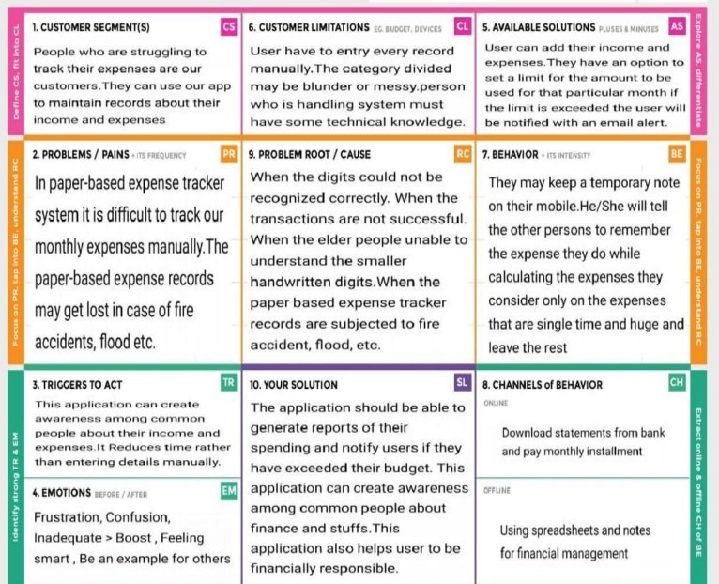

# 4. REQUIREMENT ANALYSIS

## 4.1 Functional Requirement:

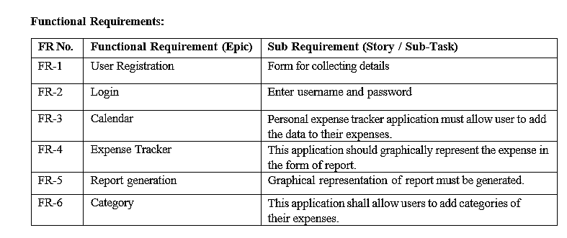

## 4.2 Non-functional Requirement:

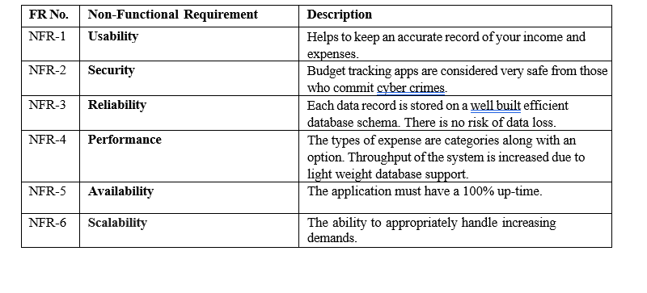

# 5. PROJECT DESIGN:

## 5.1 Dataflow Diagram:

A Data Flow Diagram (DFD) is a traditional visual representation of the information flows within a system. A neat and clear DFD can depict the right amount of the system requirement graphically. It shows how data enter and leaves the system, what changes the information, and where data is stored.

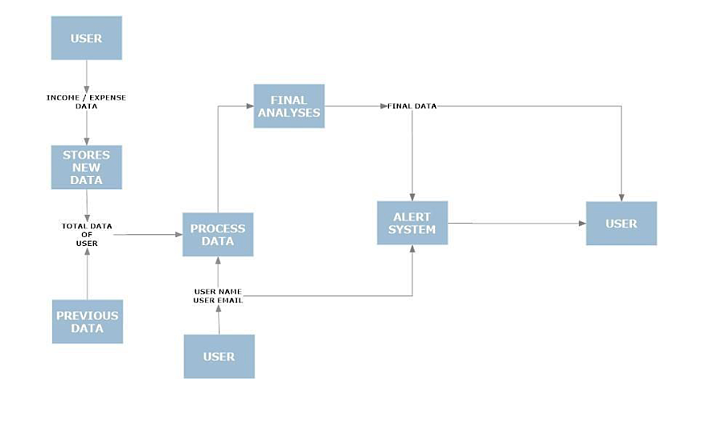

## 5.2 Solution And Technical Architecture:

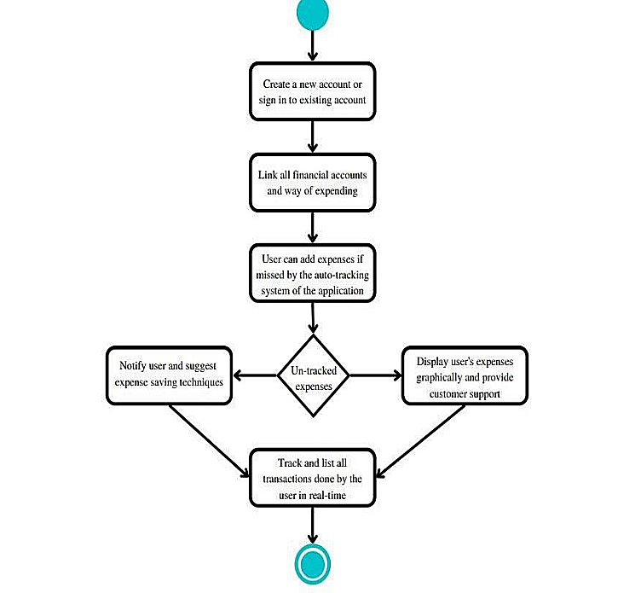

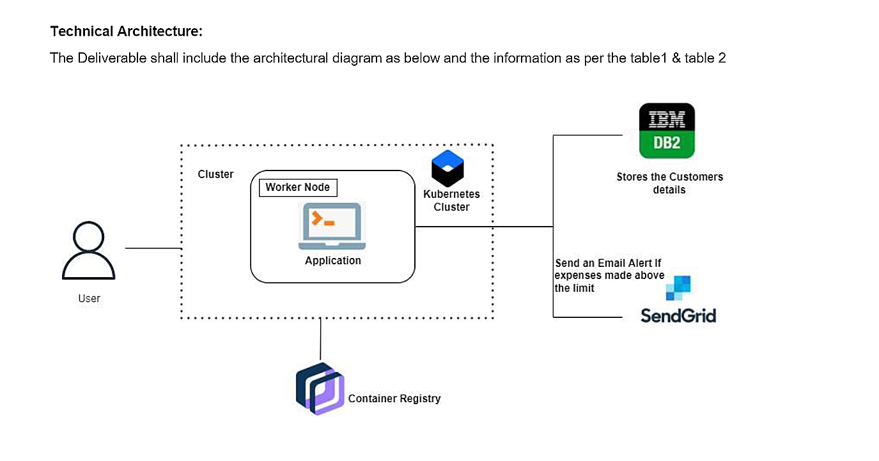

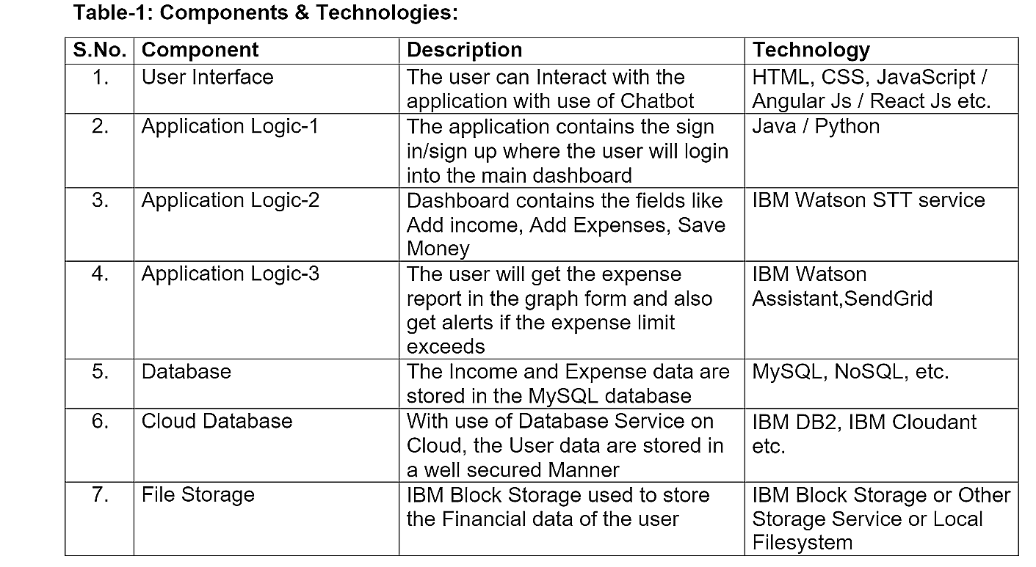

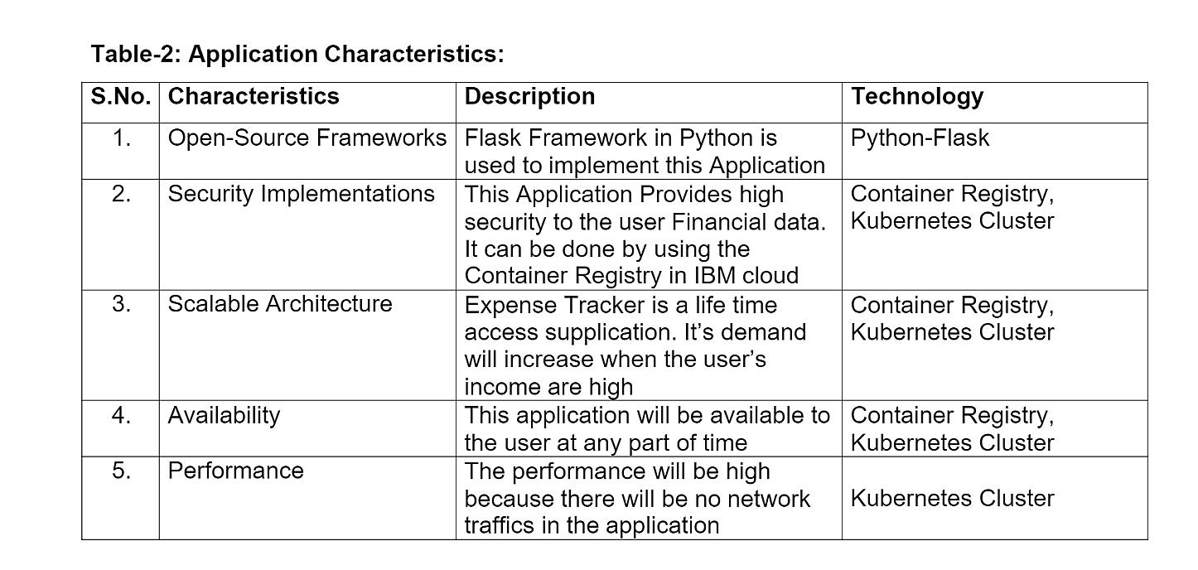

# 6. PROJECT PLANNING AND SCHEDULING :

## 6.1 Sprint Planning & Estimation:

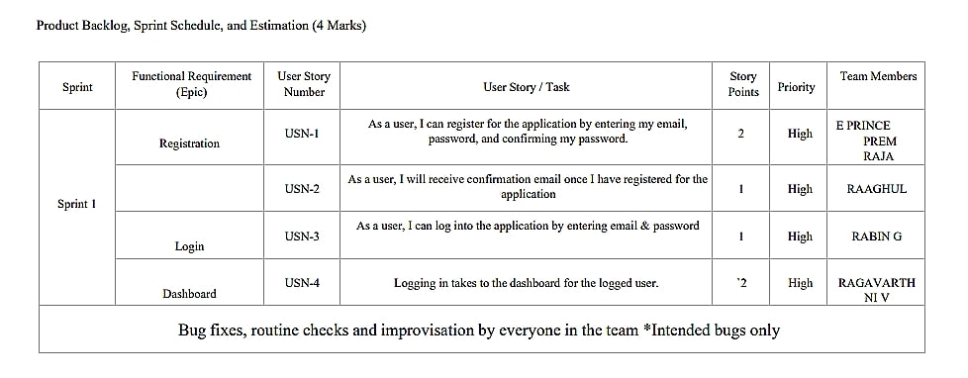

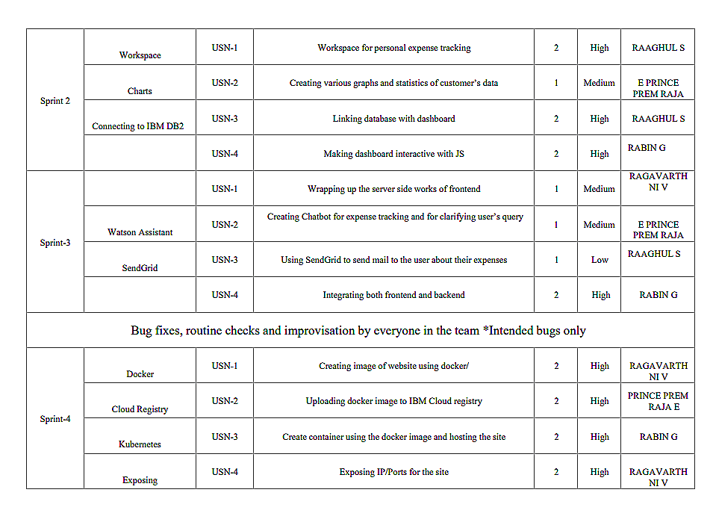

## 6.2 Sprint Delivery Schedule:

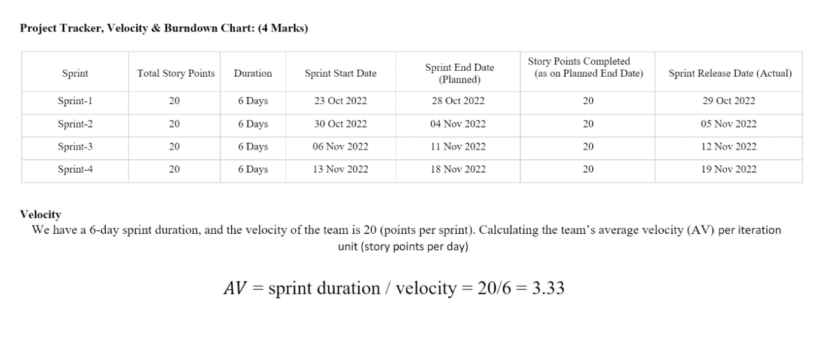

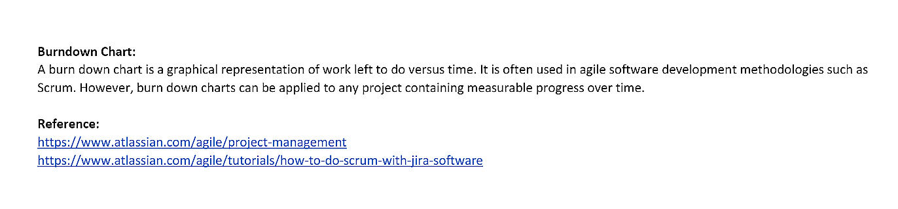

# 7. CODING

## 7.1 Source Code:

**Login.html:**

<!doctypehtml>

<htmllang="en">

<head>

<!--Required metatags -->

<metacharset="utf-8">

<metaname="viewport"content="width=device-width,initial-scale=1">

<!--Bootstrap CSS-->

<linkhref=["ht](https://cdn.jsdelivr.net/npm/bootstrap%405.0.2/dist/css/bootstrap.min.css)t[ps://cdn.jsdelivr.net/npm/bootstrap@5.0.2/dist/css/bootstrap.min.css](https://cdn.jsdelivr.net/npm/bootstrap%405.0.2/dist/css/bootstrap.min.css)"

rel="stylesheet"integrity="sha384-

EVSTQN3/azprG1Anm3QDgpJLIm9Nao0Yz1ztcQTwFspd3yD65VohhpuuCOmLASjC"

crossorigin="anonymous">

<title>Login</title>

</head>

<scriptsrc=["http](https://cdn.jsdelivr.net/npm/bootstrap%405.0.2/dist/js/bootstrap.bundle.min.j)s[://cdn.jsdelivr.net/npm/bootstrap@5.0.2/dist/js/bootstrap.bundle.min.j](https://cdn.jsdelivr.net/npm/bootstrap%405.0.2/dist/js/bootstrap.bundle.min.j)s"

integrity="sha384-

MrcW6ZMFYlzcLA8Nl+NtUVF0sA7MsXsP1UyJoMp4YLEuNSfAP+JcXn/tWtIaxVXM"

crossorigin="anonymous"></script>

<bodystyle="background-color:#B2D3C2">

<divclass="containermt-3">

<h1style="color: black;text-align: center;">

Personal ExpenseTracker <imgsrc="bank.png"style="width:50px;height:50px;">

</h1>

<divclass="containermt-5" style="width:600px;">

<divclass="cardshadow-lg bg-whiterounded">

<divclass="card-header"style="text-align:center;">

<h4>Login</h4>

</div>

<divclass="card-body">

<formaction="/login"method="POST">

<divclass="mb-3">

<labelfor="email"class="form-label">Email:</label>

<input type="email" class="form-control" name="email" id="email"placeholder="[abc@gmail.com">](mailto:abc@gmail.com)

</div>

<divclass="mb-3">

<label for="passowrd"class="form-label">Password:</label>

<input type="password" class="form-control" name="password"id="password"></input>

</div>

<button type="submit" style="background-color:#00AD83;bordercolor:#00AD83;border-radius:5px;">Login</button>

</form>

</div>

<divclass="card-footertext-muted"style="text-align:center">

Newuser? <span><ahref="registration.html">RegisterHere</a></span>

</div>

</div>

</div>

</div>

</body>

</html>

**Registration Page****.html:**

<!doctypehtml>

<htmllang="en">

<head>

<!--Required metatags -->

<meta charset="utf-8">

<metaname="viewport"content="width=device-width,initial-scale=1">

<!--Bootstrap CSS-->

<linkhref=["ht](https://cdn.jsdelivr.net/npm/bootstrap%405.0.2/dist/css/bootstrap.min.css)t[ps://cdn.jsdelivr.net/npm/bootstrap@5.0.2/dist/css/bootstrap.min.css](https://cdn.jsdelivr.net/npm/bootstrap%405.0.2/dist/css/bootstrap.min.css)"

rel="stylesheet"integrity="sha384-

EVSTQN3/azprG1Anm3QDgpJLIm9Nao0Yz1ztcQTwFspd3yD65VohhpuuCOmLASjC"

crossorigin="anonymous">

<title>Registration</title>

</head>

<scriptsrc=["http](https://cdn.jsdelivr.net/npm/bootstrap%405.0.2/dist/js/bootstrap.bundle.min.j)s[://cdn.jsdelivr.net/npm/bootstrap@5.0.2/dist/js/bootstrap.bundle.min.j](https://cdn.jsdelivr.net/npm/bootstrap%405.0.2/dist/js/bootstrap.bundle.min.j)s"

integrity="sha384-

MrcW6ZMFYlzcLA8Nl+NtUVF0sA7MsXsP1UyJoMp4YLEuNSfAP+JcXn/tWtIaxVXM"

crossorigin="anonymous"></script>

<bodystyle="background-color:#B2D3C2">

<divclass="containermt-3">

<h1style="color: black;text-align: center;">

Personal ExpenseTracker <imgsrc="bank.png"style="width:50px;height:45px;">

</h1>

<divclass="containermt-2" style="width:600px;">

<divclass="cardshadow-lg bg-whiterounded">

<divclass="card-header"style="text-align:center;">

<h4>RegistrationForm</h4>

</div>

<divclass="card-body">

<formaction="/"method="POST">

<divclass="mb-3">

<labelfor="email"class="form-label">Email:</label>

<input type="email" class="form-control" name="email" id="email"placeholder="[abc@gmail.com">](mailto:abc@gmail.com)

</div>

<divclass="mb-3">

<labelfor="passowrd"class="form-label">Password:</label>

<input type="password" class="form-control" name="password"id="password"></input>

<p style="color: gray;" class="mt-3">Please make sure that the passwordmeets the following requirements:</p>

<ol style="color: gray;"><li>Minimum of 8 characters</li><li>Containsan upper case and aspecialcharacter</li></ol>

</div>

<div class="mb-3">

<labelfor="confirmpassword"class="form-label">ConfrimPassword:

</label>

<input type="password" class="form-control" name="confirmpassword"id="confirmpassword"placeholder="****">

</div>

<divclass="mb-3">

<labelfor="wallet"class="form-label">InitialWallet Amount(Rs):

</label>

<input type="number" class="form-control" name="wallet" id="wallet"placeholder="10000.00">

</div>

<button type="submit" style="background-color:#00AD83;bordercolor:#00AD83;border-radius:5px;">Register</button>

</form>

</div>

<divclass="card-footertext-muted"style="text-align:center">

Alreadyan existinguser? <span><ahref="login">LoginHere</a></span>

</div>

</div>

</div>

</div>

</body>

</html>

**Add Expense.html**:

<!doctypehtml>

<htmllang="en">

<head>

<!--Required metatags -->

<metacharset="utf-8">

<metaname="viewport"content="width=device-width,initial-scale=1">

<!--Bootstrap CSS-->

<linkhref=["ht](https://cdn.jsdelivr.net/npm/bootstrap%405.0.2/dist/css/bootstrap.min.css)t[ps://cdn.jsdelivr.net/npm/bootstrap@5.0.2/dist/css/bootstrap.min.css](https://cdn.jsdelivr.net/npm/bootstrap%405.0.2/dist/css/bootstrap.min.css)"

rel="stylesheet"integrity="sha384-

EVSTQN3/azprG1Anm3QDgpJLIm9Nao0Yz1ztcQTwFspd3yD65VohhpuuCOmLASjC"

crossorigin="anonymous">

<title>AddExpense</title>

</head>

<scriptsrc=["http](https://cdn.jsdelivr.net/npm/bootstrap%405.0.2/dist/js/bootstrap.bundle.min.j)s[://cdn.jsdelivr.net/npm/bootstrap@5.0.2/dist/js/bootstrap.bundle.min.j](https://cdn.jsdelivr.net/npm/bootstrap%405.0.2/dist/js/bootstrap.bundle.min.j)s"

integrity="sha384-

MrcW6ZMFYlzcLA8Nl+NtUVF0sA7MsXsP1UyJoMp4YLEuNSfAP+JcXn/tWtIaxVXM"

crossorigin="anonymous"></script>

<divclass="container-fluid">

<divclass="rowflex-nowrap">

<div class="col-auto col-md-3 col-xl-2 px-sm-2 px-0" style="background-color:#B2D3C2">

<div class="d-flex flex-column align-items-center align-items-sm-start px-3 pt- 2

min-vh-100"style="color:black">

<p class="d-flex align-items-center pb-3 mb-md-0 me-md-auto text-white textdecoration-none">

<span class="fs-5 d-none d-sm-inline" style="color:black; font-weight:bold;">Personal Expense Tracker</span>

<imgsrc="bank.png"style="width:50px;height:50px;">

</p>

<ul class="nav nav-pills flex-column mb-sm-auto mb-0 align-items-centeralignitems-sm-start" id="menu">

<liclass="nav-itemmt-2">

<a href="dashboard.html" class="nav-link align-middle px-0"style="color:black;">

<span class="ms-1 d-none d-sm-inline">Home</span><imgsrc="houseoutline.svg"style="width:20px;height:20px;margin-left:5px;">

</a>

</li>

<li class="nav-item mt-2" style="background-color:#00AD83; height: 50px;width: 150px;border-radius: 5px;" >

<a href="addexpense.html" class="nav-link px-0 align-middle"style="color:black;">

<span class="ms-1 d-none d-sm-inline">Add Expense</span><imgsrc="pay.png"style="width:20px;height:20px;margin-left:5px;">

</a>

</li>

<liclass="nav-itemmt-2">

<a href="modifyexpense.html" class="nav-link px-0 align-middle"style="color:black;">

<span class="ms-1 d-none d-sm-inline">Modify Expense</span><imgsrc="edit_icon.svg"style="width:20px;height:20px;margin-left:5px;">

</a>

</li>

<liclass="nav-itemmt-2">

<a href="analysis.html" class="nav-link px-0 align-middle"style="color:black;">

<span class="ms-1 d-none d-sm-inline">View Analysis</span><imgsrc="graph.png"style="width:20px;height:20px;margin-left:5px;">

</a>

</li>

<liclass="nav-itemmt-2">

<a href="rewards.html" class="nav-link px-0 align-middle"style="color:black;">

<span class="ms-1 d-none d-sm-inline">Rewards & Goals</span><imgsrc="reward.png"style="width:20px;height:20px;margin-left:5px;">

</a>

</li>

</ul>

</div>

</div>

<divclass="col py-3"style="background-color:black">

<h3style="color:white;text-align: center;">Addexpense</h3>

<divclass="containermt-3" style="width:600px;">

<divclass="cardshadow-lg bg-whiterounded">

<divclass="card-header"style="text-align:center;">

<span style="display:inline-flex"><h4>Expense Made</h4><imgsrc="pay.png"style="margin-left:10px;width:30px;height:30px"></span>

</div>

<divclass="card-body">

<form>

<div class="mb-3">

<labelfor="amountspent"class="form-label">AmountSpent: (Rs)

</label>

<input type="number" class="form-control" name="amountspent"id="amountspent"placeholder="100.00">

</div>

<divclass="mb-3">

<labelfor="expensecategory"class="form-label">ExpenseCategory:

</label>

<input type="text" class="form-control" name="expensecategory"id="expensecategory"></input>

</div>

<divclass="mb-3">

<label for="date"class="form-label">Dateof Expense:</label>

<input type="date" class="form-control" name="date"id="date"></input>

</div>

</label>

<divclass="mb-3">

<labelfor="description"class="form-label">Descriptionof Expense:

<input type="text" class="form-control" name="description"id="description"></input>

</div>

</form>

</div>

<divclass="card-footertext-muted"style="text-align:center">

<button type="submit" style="background-color:#00AD83;bordercolor:#00AD83;border-radius:5px;">SubmitExpense</button>

</div>

</div>

</div>

</div>

</div>

</div>

</html>

**Python code To Connect with db****:**

import ibm_db dictionary={}

defprintTableData(conn):

sql ="SELECT *FROM userdetails"out = ibm_db.exec_immediate(conn, sql)document = ibm_db.fetch_assoc(out)while document!= False:

dictionary.update({document['USERNAME']:

documen t['PASSWORD']}) document = ibm_db.fetch_assoc(out) def

insertTableData(conn,rollno,username,email,pass word):sql="INSERT INTO userdetails(rollno,username,email,password)VALUES ({},'{}','{}','{}')".format(rollno,username,ema il,password) out =ibm_db.exec_immediate(conn,sql)

print('Number of affected rows : ',ibm_db.num_rows(out),"\n")defupdateTableData(conn,rollno,username,email,password):

sql = "UPDATE userdetails SET (username,email,password)=('{}','{}','{}')WHERE

rollno={}".format(username,email,password,rolln o) out =ibm_db.exec_immediate(conn,sql)

print('Number of affected rows : ', ibm_db.num_rows(out), "\n")defdeleteTableData(conn,rollno):

sql= "DELETEFROM userdetailsWHERErollno={}".format(rollno)

out=ibm_db.exec_immediate(conn,sql) print('Numberof affectedrows :', ibm_db.num_rows(out),"\n")

try:

conn=ibm_db.connect("DATABASE=bludb;HOSTNAME=2f3279a5-73d1-4859-88f0-

a6c3e6b4b907.c3n41cmd0nqnrk39u98g.databases.appdomain.cloud;PORT=30756;Security=

SSL;SSLServerCertificate=DigiCertGlobalRootCA.crt;UID=ctb99199;PWD=GybYxLw1rH

z86oSh;","","")

print("Db connected")except:

print("Error")

from flask import Flask,render_template,request,url_for,sessionapp=Flask( name)

@app.route("/")@app.route("/login",methods=['POST','GET'])def login():

ifrequest.method=="POST":

printTableData(conn)username=request.form['username']password=request.form['password']

try:if dictionary[username]== passwordand usernamein dictionary:

**App.py**

from flaskimport Flask,render_template, requestimport logging

from logging import Formatter, FileHandlerfrom forms import*

importos

app =Flask(name)app.config.from_object('config')

@app.route('/') defhome():

returnrender_template('pages/placeholder.home.html')

@app.route('/about') defabout():

returnrender_template('pages/placeholder.about.html')

@app.route('/login') deflogin():

form= LoginForm(request.form)

returnrender_template('forms/login.html',form=form)

@app.route('/register') defregister():

form=RegisterForm(request.form)

returnrender_template('forms/register.html',form=form)

@app.route('/forgot') defforgot():

form=ForgotForm(request.form)

returnrender_template('forms/forgot.html',form=form)

@app.errorhandler(500) def internal_error(error):#db_session.rollback()

returnrender_template('errors/500.html'),500

@app.errorhandler(404) defnot_found_error(error):

returnrender_template('errors/404.html'),404

ifnot app.debug:

file_handler=FileHandler('error.log')

file_handler.setFormatter(

Formatter('%(asctime)s%(levelname)s:%(message)s [in

%(pathname)s:%(lineno)d]')

)

app.logger.setLevel(logging.INFO)file_handler.setLevel(logging.INFO)app.logger.addHandler(file_handler)app.logger.info('errors')

## # Launch.

##ifname=='main':app.run()

**Config.py**

importos

#Grabs thefolder wherethe scriptruns.

basedir=os.path.abspath(os.path.dirname(file))

#Enable debugmode.

DEBUG = True

# Secret key for session management. You can generate random strings here: # https://randomkeygen.com/

SECRET_KEY =' '

#Connect tothe database

SQLALCHEMY_DATABASE_URI = 'sqlite:///' + os.path.join(basedir,'database.db')

**Fabfile**

from fabric.api import local, settings, abortfromfabric.contrib.consoleimport confirm

#prepare fordeployment

deftest():

with settings(warn_only=True):result = local(

"pythontest_tasks.py -v&& pythontest_users.py -v",capture=True

)

if result.failed and not confirm("Tests failed. Continue?"):abort("Aborted atuser request.")

defcommit():

message = raw_input("Enter a git commit message: ")local("git add. &&git commit-am'{}'".format(message))

defpush():

local("git pushorigin master")

def prepare(): test()commit() push()

#deploy toheroku

defpull():

local("gitpull originmaster")

defheroku():

local("gitpush herokumaster")

def heroku_test(): local(

"herokurun pythontest_tasks.py -v&& herokurun pythontest_users.py -

v"

)

def deploy(): pull()

test() commit()heroku() heroku_test()

#rollback

def rollback(): local("herokurollback")

**Forms.py**

fromflask_wtf importForm

fromwtforms importTextAreaField,PasswordField

fromwtforms.validators importDataRequired, EqualTo,Length

#Set yourclasses here.

class RegisterForm(Form): name= TextAreaField(

'Username',validators=[DataRequired(),Length(min=6, max=25)]

)

email= TextAreaField(

'Email',validators=[DataRequired(),Length(min=6, max=40)]

)

password =PasswordField(

'Password',validators=[DataRequired(),Length(min=6, max=40)]

)

confirm = PasswordField( 'Repeat Password', [DataRequired(),

EqualTo('password',message='Passwords mustmatch')]

)

classLoginForm(Form):

name = TextAreaField('Username', [DataRequired()])password =PasswordField('Password',[DataRequired()])

class ForgotForm(Form): email= TextAreaField(

'Email',validators=[DataRequired(),Length(min=6, max=40)]

)

**Models.py**

fromsqlalchemy importcreate_engine

from sqlalchemy.orm import scoped_session, sessionmakerfromsqlalchemy.ext.declarativeimport declarative_base

# from sqlalchemy import Column, Integer, String# from app importdb

engine = create_engine('sqlite:///database.db', echo=True)db_session=scoped_session(sessionmaker(autocommit=False,

autoflush=False, bind=engine))

Base= declarative_base()

Base.query=db_session.query_property()

Base.metadata.create_all(bind=engine)

**Add.html**

<!DOCTYPEhtml>

<htmllang="en">

<head>

<link rel="stylesheet"href=["ht](https://cdn.jsdelivr.net/npm/bootstrap%404.5.3/dist/css/bootstrap.min.css)t[ps://cdn.jsdelivr.net/npm/bootstrap@4.5.3/dist/css/bootstrap.min.css](https://cdn.jsdelivr.net/npm/bootstrap%404.5.3/dist/css/bootstrap.min.css)"integrity="sha384-TX8t27EcRE3e/ihU7zmQxVncDAy5uIKz4rEkgIXeMed4M0jlfIDPvg6uqKI2xXr2"crossorigin="anonymous">

<scriptsrc=["http](https://cdn.jsdelivr.net/npm/chart.js%403.2.1/dist/chart.min.js)s[://cdn.jsdelivr.net/npm/chart.js@3.2.1/dist/chart.min.js](https://cdn.jsdelivr.net/npm/chart.js%403.2.1/dist/chart.min.js)"></script>

<script src="https://code.jquery.com/jquery-3.5.1.slim.min.js"integrity="sha384-DfXdz2htPH0lsSSs5nCTpuj/zy4C+OGpamoFVy38MVBnE+IbbVYUew+OrCXaRkfj" crossorigin="anonymous"></script>

<scriptsrc=["http](https://cdn.jsdelivr.net/npm/popper.js%401.16.1/dist/umd/popper.min.js)s[://cdn.jsdelivr.net/npm/popper.js@1.16.1/dist/umd/popper.min.js](https://cdn.jsdelivr.net/npm/popper.js%401.16.1/dist/umd/popper.min.js)"integrity="sha384-

9/reFTGAW83EW2RDu2S0VKaIzap3H66lZH81PoYlFhbGU+6BZp6G7niu73

5Sk7lN"crossorigin="anonymous"></script>

<scriptsrc="https://stackpath.bootstrapcdn.com/bootstrap/4.5.2/js/bootstrap.min.js"integrity="sha384-B4gt1jrGC7Jh4AgTPSdUtOBvfO8shuf57BaghqFfPlYxofvL8/KUEfYiJOMMV

+rV"crossorigin="anonymous"></script>

<link rel="stylesheet"href="https://pro.fontawesome.com/releases/v5.10.0/css/all.css"integrity="sha384-AYmEC3Yw5cVb3ZcuHtOA93w35dYTsvhLPVnYs9eStHfGJvOvKxVfELGroGkvsg+p"crossorigin="anonymous"/>

<title>Document</title>

</head>

<body>

<nav class="navbar sticky-top navbar-expand-lg navbar-light"style="background-color: #e3f2fd;">

<aclass="navbar-brand"href="#">MyBudget</a>

<button class="navbar-toggler" type="button" data-toggle="collapse" data-target="#navbarSupportedContent" aria-controls="navbarSupportedContent"aria-expanded="false" aria-label="Togglenavigation">

<spanclass="navbar-toggler-icon"></span>

</button>

<divclass="collapsenavbar-collapse"id="navbarSupportedContent">

<ulclass="navbar-navmr-auto">

<liclass="nav-itemactive">

<a class="nav-link"href="#home.html">Home</a>

</li>

<liclass="nav-item">

<aclass="nav-link"href="add.html">Add</a>

</li>

<liclass="nav-item">

<aclass="nav-link"href="display.html">History</a>

</li>

<liclass="nav-item">

<aclass="nav-link"href="limit.html">LIMIT</a>

</li>

<liclass="nav-itemdropdown">

<a class="nav-link dropdown-toggle" href="#" id="navbarDropdown"role="button" data-toggle="dropdown" aria-haspopup="true" aria-expanded="false">

Report

</a>

<divclass="dropdown-menu"aria-labelledby="navbarDropdown">

<aclass="dropdown-item"href="today.html">Today</a>

<aclass="dropdown-item"href="month.html">Month</a>

<aclass="dropdown-item"href="year.html">Year</a>

</div>

</li>

</ul>

<div class="form-inline my-5 my-lg-1" style="position: absolute; left: 1250px;">

<ul class="navbar-nav mr-auto " > <li class="nav-item dropdown btn-group open">

<a class="btnbtn-primary"href="#"><iclass="fa fa-userfa-fw"></i>User

</a>

<a class="btn btn-primary dropdown-toggle "href="#" id="navbarDropdown"data-toggle="dropdown"aria-haspopup="true"aria-expanded="false">

</a>

<divclass="dropdown-menu"aria-labelledby="navbarDropdown">

<aclass="dropdown-item"href="#">Profile</a>

<aclass="dropdown-item"href="#">Settings</a>

<aclass="dropdown-item"href="#">Contact-Us</a>

<divclass="dropdown-divider"></div>

<a class="dropdown-item" style="color: crimson;" href="/logout">Log-Out <i class="fa fa-sign-out" aria-hidden="true"></i></a>

</div>

</li>

<div >

</ul>

</div>

</div>

</nav>

</div><br><br><br><br>

<divclass="container">

<divclass="row">

<div class="col-md-6">

<h3>AddExpense</h3>

<formaction="/addexpense"method="POST">

<divclass="form-group">

<labelfor="">Date</label>

<input class="form-control" type="datetime-local" name="date"id="date"></div>

<divclass="form-group"><label for="">Expensename</label>

<input class="form-control" type="text" name="expensename"id="expensename">

</div>

<divclass="form-group">

<labelfor="">ExpenseAmount</label>

<input class="form-control" type="number" min="0" name="amount"id="amount">

</div>

<divclass="form-group">

<labelfor=""></label>

<selectclass="form-control"name="paymode"id="paymode">

<optionselectedhidden>Pay-Mode</option>

<optionname="cash"value="cash">cash</option>

<option name="debitcard"value="debitcard">debitcard</option>

<option name="creditcard"value="creditcard">creditcard</option>

<option name="epayment"value="epayment">epayment</option>

<option name="onlinebanking"value="onlinebanking">onlinebanking</option>

</select>

<div class="form-group">

<label for=""></label>

<selectclass="form-control"name="category"id="category">

<optionselectedhidden>Category</option>

<option name= "food"value="food">food</option>

<option name = "entertainment"value="entertainment">Entertainment</option>

<optionname ="business"value="business">Business</option>

<optionname ="rent"value="rent">Rent</option>

<optionname ="EMI"value="EMI">EMI</option>

<optionname ="other"value="other">other</option>

</select>

</div>

<inputclass="btnbtn-danger"type="submit"value="add"id="">

</form>

<div style="position: relative; left: 590px; top: -460px;"class="imagge">

<img width="90%" height="90%"src="C:\Users\rithi\Desktop\IBM\images\expense61.webp" class="roundedfloat-left"alt="...">

</div>

</div>

</div>

</div>

</body>

</html>

**Display.html**

<!DOCTYPEhtml>

<htmllang="en">

<head>

<link rel="stylesheet"href=["ht](https://cdn.jsdelivr.net/npm/bootstrap%404.5.3/dist/css/bootstrap.min.css)t[ps://cdn.jsdelivr.net/npm/bootstrap@4.5.3/dist/css/bootstrap.min.css](https://cdn.jsdelivr.net/npm/bootstrap%404.5.3/dist/css/bootstrap.min.css)"integrity="sha384-TX8t27EcRE3e/ihU7zmQxVncDAy5uIKz4rEkgIXeMed4M0jlfIDPvg6uqKI2xXr2"crossorigin="anonymous">

<scriptsrc=["http](https://cdn.jsdelivr.net/npm/chart.js%403.2.1/dist/chart.min.js)s[://cdn.jsdelivr.net/npm/chart.js@3.2.1/dist/chart.min.js](https://cdn.jsdelivr.net/npm/chart.js%403.2.1/dist/chart.min.js)"></script>

<scriptsrc="https://code.jquery.com/jquery-3.5.1.slim.min.js"integrity="sha384-

DfXdz2htPH0lsSSs5nCTpuj/zy4C+OGpamoFVy38MVBnE+IbbVYUew+OrCXaRkfj" crossorigin="anonymous"></script>

<scriptsrc=["http](https://cdn.jsdelivr.net/npm/popper.js%401.16.1/dist/umd/popper.min.js)s[://cdn.jsdelivr.net/npm/popper.js@1.16.1/dist/umd/popper.min.js](https://cdn.jsdelivr.net/npm/popper.js%401.16.1/dist/umd/popper.min.js)"integrity="sha384-9/reFTGAW83EW2RDu2S0VKaIzap3H66lZH81PoYlFhbGU+6BZp6G7niu73

5Sk7lN"crossorigin="anonymous"></script>

<scriptsrc="https://stackpath.bootstrapcdn.com/bootstrap/4.5.2/js/bootstrap.min.js"integrity="sha384-B4gt1jrGC7Jh4AgTPSdUtOBvfO8shuf57BaghqFfPlYxofvL8/KUEfYiJOMMV

+rV"crossorigin="anonymous"></script>

<link rel="stylesheet"href="https://pro.fontawesome.com/releases/v5.10.0/css/all.css"integrity="sha384-AYmEC3Yw5cVb3ZcuHtOA93w35dYTsvhLPVnYs9eStHfGJvOvKxVfELGroGkvsg+p"crossorigin="anonymous"/>

<title>Document</title>

</head>

<body>

<nav class="navbar sticky-top navbar-expand-lg navbar-light"style="background-color: #e3f2fd;">

<aclass="navbar-brand"href="#">MyBudget</a>

<button class="navbar-toggler" type="button" data-toggle="collapse" data-target="#navbarSupportedContent" aria-controls="navbarSupportedContent"aria-expanded="false" aria-label="Togglenavigation">

<spanclass="navbar-toggler-icon"></span>

</button>

<divclass="collapsenavbar-collapse"id="navbarSupportedContent">

<ulclass="navbar-navmr-auto">

<liclass="nav-itemactive">

<aclass="nav-link"href>Home </a>

</li>

<liclass="nav-item">

<aclass="nav-link"href="add.html">Add</a>

</li>

<liclass="nav-item">

<aclass="nav-link"href="display.html">History</a>

</li>

<liclass="nav-item">

<aclass="nav-link"href="limit.html">LIMIT</a>

</li>

<liclass="nav-itemdropdown">

<a class="nav-link dropdown-toggle" href="#" id="navbarDropdown"role="button" data-toggle="dropdown" aria-haspopup="true" aria-expanded="false">

Report

</a>

<divclass="dropdown-menu"aria-labelledby="navbarDropdown">

<aclass="dropdown-item"href="today.html">Today</a>

<aclass="dropdown-item"href="month.html">Month</a>

<aclass="dropdown-item"href="year.html">Year</a>

</div>

</li>

</ul>

<div class="form-inline my-5 my-lg-1" style="position: absolute; left: 1250px;">

<ul class="navbar-nav mr-auto " > <li class="nav-item dropdown btn-group open">

<aclass="btnbtn-primary"href="#"><iclass="fa fa-userfa-fw"></i>User

</a>

<a class="btn btn-primary dropdown-toggle "href="#" id="navbarDropdown"data-toggle="dropdown"aria-haspopup="true"aria-expanded="false">

</a>

<divclass="dropdown-menu"aria-labelledby="navbarDropdown">

<aclass="dropdown-item"href="#">Profile</a>

<aclass="dropdown-item"href="#">Settings</a>

<aclass="dropdown-item"href="#">Contact-Us</a>

<divclass="dropdown-divider"></div>

<a class="dropdown-item" style="color: crimson;" href="/logout">Log-Out <i class="fa fa-sign-out"aria-hidden="true"></i></a>

</div>

</li>

<div >

</ul>

</div>

</div>

</nav>

<divclass="container ">

<h3class="mt-3">EXPENSES</h3>

<divclass="row">

<divclass="col-md-12">

<divclass="cardshadow-sm mb-2bg-white rounded"></div>

<divclass="card-body">

<divclass="row">

<divclass="col-md-2">

<spanclass="btnbtn-outline-dark">{{row[2]}}</span></div>

<divclass="col-md-2mt-3"><H6>{{row[3]}}</H6></div>

<div class="col-md-2 mt-3" > ₹<span style=" color: rgb(255, 0, 0) ">{{row[4]}} </div>

<divclass="col-md-2mt-3">

<spanclass="badgebadge-pillbadge-info">{{row[5]}}</span>

</div>

<divclass="col-md-2mt-3">

<spanclass="badgebadge-primary">{{row[6]}}</span>

</div>

<div class="col-md-1mt-3">

<ahref="edit.html" class="btnbtn-smbtn-success">Edit</a>

</div>

<divclass="col-md-1mt-3">

<a href="/delete/{{row[0]}}" class="btn btn-sm btnDeletebtn-success">Delete</a>

</div>

</div>

</div>

</div>

</div>

<!--whenno DATA-Found-->

<divclass="cardshadow-sm mb-2bg-white rounded"></div>

<divclass="card-body">

<img width=60% src="C:\Users\rithi\Desktop\IBM\images\nodata-found2.webp">

</div>

<divclass="row">

<div class="col-md-6">

<h3class="mt-5">ExpenseBreakdown</h3>

<divclass="card shadowmb-2 bg-whiterounded-bottom">

<divclass="card-body ">

<divclass="row">

<divclass="col-md-6">Food</div>

<divid="tfood"class="col-md-6"> {{t_food}} </div>

</div>

</div>

</div>

</div>

<divclass="card shadowmb-2 bg-whiterounded">

<divclass="card-body">

<divclass="row">

<divclass="col-md-6">Entertainment</div>

<divid="tentertainment"class="col-md-6">{{ t_entertainment}}

</div>

</div>

</div>

<divclass="card shadowmb-2 bg-whiterounded">

<divclass="card-body">

<divclass="row">

<divclass="col-md-6">Business</div>

<divid="tbusiness"class="col-md-6">{{t_business}} </div>

</div>

</div>

</div>

<divclass="card shadowmb-2 bg-whiterounded">

<divclass="card-body">

<divclass="row">

<divclass="col-md-6">Rent</div>

<divid="trent"class="col-md-6">{{ t_rent}} </div>

</div>

</div>

</div>

<divclass="card shadowmb-2 bg-whiterounded">

<divclass="card-body">

<divclass="row">

<divclass="col-md-6">EMI</div>

<divid="temi"class="col-md-6">{{t_EMI }} </div>

</div>

</div>

</div>

<divclass="card shadowmb-2 bg-whiterounded">

<divclass="card-body">

<div class="row">

<divclass="col-md-6">Other</div>

<divid="tother"class="col-md-6">{{ t_other}}</div>

</div>

</div>

</div>

<divclass="card shadowmb-2 btn-outline-dangerrounded-pill">

<divclass="card-body">

<divclass="row">

<divclass="col-md-6">Total</div>

<divclass="col-md-6">₹{{total}} </div>

</div>

</div>

</div>

</div>

<divclass="col-md-6">

<canvasid="myChart"width="400"height="400"></canvas>

<script>

let food = document.getElementById('tfood').innerHTMLlet entertainment =

document.getElementById('tentertainment').innerHTML

let business = document.getElementById('tbusiness').innerHTMLlet rent=document.getElementById('trent').innerHTML

let emi=document.getElementById('temi').innerHTMLlet other=document.getElementById('tother').innerHTML

varctx =document.getElementById('myChart').getContext('2d');

var myChart = new Chart(ctx, {type: 'doughnut',

data: {

labels: ['Food', 'Entertainment', 'Business', 'Rent', 'EMI', 'Other'], datasets: [{

label:'Expenses Chart',

data: [food, entertainment, business, rent, emi, other],backgroundColor: [

'rgb(255,99, 132)',

'rgb(0,0, 0)',

'rgb(255,205, 86)',

'rgb(201,203, 207)',

'rgb(54,162, 235)',

'rgb(215,159, 64)'

],

}]

},

options: { responsive: true, plugins: {

legend:{

position:'bottom',

},

title: {display: true,

text:'EXPENSE BREAKDOWN'

}

}

}

});

</script>

</div>

</div>

</div>

</body>

</html>

**Base.html**

<!DOCTYPEhtml>

<htmllang="en">

<head>

<link rel="stylesheet"href=["ht](https://cdn.jsdelivr.net/npm/bootstrap%404.5.3/dist/css/bootstrap.min.css)t[ps://cdn.jsdelivr.net/npm/bootstrap@4.5.3/dist/css/bootstrap.min.css](https://cdn.jsdelivr.net/npm/bootstrap%404.5.3/dist/css/bootstrap.min.css)"integrity="sha384-TX8t27EcRE3e/ihU7zmQxVncDAy5uIKz4rEkgIXeMed4M0jlfIDPvg6uqKI2xXr2"crossorigin="anonymous">

<scriptsrc=["http](https://cdn.jsdelivr.net/npm/chart.js%403.2.1/dist/chart.min.js)s[://cdn.jsdelivr.net/npm/chart.js@3.2.1/dist/chart.min.js](https://cdn.jsdelivr.net/npm/chart.js%403.2.1/dist/chart.min.js)"></script>

<script src="https://code.jquery.com/jquery-3.5.1.slim.min.js"integrity="sha384-DfXdz2htPH0lsSSs5nCTpuj/zy4C+OGpamoFVy38MVBnE+IbbVYUew+OrCXaRkfj" crossorigin="anonymous"></script>

<scriptsrc=["http](https://cdn.jsdelivr.net/npm/popper.js%401.16.1/dist/umd/popper.min.js)s[://cdn.jsdelivr.net/npm/popper.js@1.16.1/dist/umd/popper.min.js](https://cdn.jsdelivr.net/npm/popper.js%401.16.1/dist/umd/popper.min.js)"integrity="sha384-9/reFTGAW83EW2RDu2S0VKaIzap3H66lZH81PoYlFhbGU+6BZp6G7niu73

5Sk7lN"crossorigin="anonymous"></script>

<scriptsrc="https://stackpath.bootstrapcdn.com/bootstrap/4.5.2/js/bootstrap.min.js"integrity="sha384-B4gt1jrGC7Jh4AgTPSdUtOBvfO8shuf57BaghqFfPlYxofvL8/KUEfYiJOMMV

+rV"crossorigin="anonymous"></script>

<link rel="stylesheet"href="https://pro.fontawesome.com/releases/v5.10.0/css/all.css"integrity="sha384-AYmEC3Yw5cVb3ZcuHtOA93w35dYTsvhLPVnYs9eStHfGJvOvKxVfELGroGkvsg+p"crossorigin="anonymous"/>

<title>Document</title>

</head>

<body>

<nav class="navbar sticky-top navbar-expand-lg navbar-light"style="background-color: #e3f2fd;">

<aclass="navbar-brand"href="#">MyBudget</a>

<button class="navbar-toggler" type="button" data-toggle="collapse" data-target="#navbarSupportedContent" aria-controls="navbarSupportedContent"aria-expanded="false" aria-label="Togglenavigation">

<spanclass="navbar-toggler-icon"></span>

</button>

<divclass="collapsenavbar-collapse"id="navbarSupportedContent">

<ulclass="navbar-navmr-auto">

<liclass="nav-itemactive">

<a class="nav-link" href="{{ url_for('home') }}">Home <span class="sr-only">(current)</span></a>

</li>

<liclass="nav-item">

<aclass="nav-link"href="/add">Add</a>

</li>

<liclass="nav-item">

<aclass="nav-link"href="/display">History</a>

</li>

<liclass="nav-item">

<aclass="nav-link"href="/limit">LIMIT</a>

</li>

<liclass="nav-itemdropdown">

<a class="nav-link dropdown-toggle" href="#" id="navbarDropdown"role="button" data-toggle="dropdown" aria-haspopup="true" aria-expanded="false">

Report

</a>

<divclass="dropdown-menu"aria-labelledby="navbarDropdown">

<aclass="dropdown-item"href="/today">TODAY</a>

<aclass="dropdown-item"href="/month">Month</a>

<a class="dropdown-item"href="/year">Year</a>

</div>

</li>

</ul>

<div class="form-inline my-5 my-lg-1" style="position: absolute; left: 1250px;">

<ul class="navbar-nav mr-auto " > <li class="nav-item dropdown btn-group open">

<aclass="btnbtn-primary"href="#"><iclass="fa fa-userfa-fw"></i>User

</a>

<a class="btn btn-primary dropdown-toggle "href="#" id="navbarDropdown"data-toggle="dropdown"aria-haspopup="true"aria-expanded="false">

</a>

<divclass="dropdown-menu"aria-labelledby="navbarDropdown">

<aclass="dropdown-item"href="#">Profile</a>

<aclass="dropdown-item"href="#">Settings</a>

<aclass="dropdown-item"href="#">Contact-Us</a>

<divclass="dropdown-divider"></div>

<a class="dropdown-item" style="color: darkred;" href="/logout">Log-Out <i class="fa fa-sign-out" aria-hidden="true"></i></a>

</div>

</li>

<div">

</ul>

</div>

</div>

</nav>

{%block body%}

{%endblock %}

</body>

</html>

**Create.html**

{%extends 'base.html'%}

{%block body%}

<divclass="container ">

<divclass="row">

<divclass="col-md-5">

<h3class="mt-5">YEARExpense Breakdown</h3>

<divclass="card shadowmb-2 bg-whiterounded-pill">

<divclass="card-body ">

<divclass="row">

<divvalue ="month"class="col-md-6"></div>

<divclass="col-md-6">AMOUNT </div>

</div>

</div>

</div>

{%for rowin texpense%}

<divclass="card shadowmb-2 bg-whiterounded-bottom">

<divclass="card-body ">

<divclass="row">

<divid ="ttime"class="col-md-6">{{row[0]}}</div>

<divid="tamount"class="col-md-6"> {{row[1]}} </div>

</div>

</div>

</div>

{% endfor%}

</div>

</div>

<section>

<divclass="row">

<divclass="col-md-6">

<h3class="mt-5">ExpenseBreakdown BYCategory</h3>

<divclass="card shadowmb-2 bg-whiterounded-bottom">

<divclass="card-body ">

<divclass="row">

<divclass="col-md-6">Food</div>

<div id="tfood"class="col-md-6"> {{t_food}} </div>

</div>

</div>

</div>

</div>

<divclass="card shadowmb-2 bg-whiterounded">

<divclass="card-body">

<divclass="row">

<divclass="col-md-6">Entertainment</div>

<divid="tentertainment"class="col-md-6">{{ t_entertainment}}

</div>

</div>

</div>

<divclass="card shadowmb-2 bg-whiterounded">

<divclass="card-body">

<divclass="row">

<divclass="col-md-6">Business</div>

<divid="tbusiness"class="col-md-6">{{t_business}} </div>

</div>

</div>

</div>

<divclass="card shadowmb-2 bg-whiterounded">

<divclass="card-body">

<div class="row">

<divclass="col-md-6">Rent</div>

<divid="trent"class="col-md-6">{{ t_rent}} </div>

</div>

</div>

</div>

<divclass="card shadowmb-2 bg-whiterounded">

<divclass="card-body">

<divclass="row">

<divclass="col-md-6">EMI</div>

<divid="temi"class="col-md-6">{{t_EMI }} </div>

</div>

</div>

</div>

<divclass="card shadowmb-2 bg-whiterounded">

<divclass="card-body">

<divclass="row">

<divclass="col-md-6">Other</div>

<divid="tother"class="col-md-6">{{ t_other}}</div>

</div>

</div>

</div>

<div class="cardshadow mb-2btn-outline-dangerrounded-pill">

<divclass="card-body">

<divclass="row">

<divclass="col-md-6">Total</div>

<divclass="col-md-6">₹{{total}} </div>

</div>

</div>

</div>

</div>

<divclass="col-md-6">

<canvasid="myChart"width="400"height="400"></canvas>

<script>

let food = document.getElementById('tfood').innerHTMLlet entertainment =

document.getElementById('tentertainment').innerHTML

let business = document.getElementById('tbusiness').innerHTMLlet rent=document.getElementById('trent').innerHTML

let emi=document.getElementById('temi').innerHTMLlet other=document.getElementById('tother').innerHTML

var ctx = document.getElementById('myChart').getContext('2d');var myChart= newChart(ctx, {

type: 'doughnut', data:{

labels: ['Food', 'Entertainment', 'Business', 'Rent', 'EMI', 'Other'], datasets:[{

label:'Expenses Chart',

data:[food, entertainment,business, rent,emi, other],

backgroundColor: [ 'rgb(255,99, 132)',

'rgb(0,0, 0)',

'rgb(255,205, 86)',

'rgb(201,203, 207)',

'rgb(54,162, 235)',

'rgb(215,159, 64)'

],

}]

},

options: { responsive: true, plugins: {

legend:{

position:'bottom',

},

title: {display: true,

text:'EXPENSE BREAKDOWN'

}

}

}

});

</script>

</div>

</div>

</div>

</section>

</div>

{%endblock %}

**Limit.html**

{%extends 'base.html'%}

{%block body%}

<p>Currently yourMONTHLY limitis ₹{{y}} </p>

<formaction="/limitnum"method="POST">

<p> ENTERthe MONTHLYLIMIT toavoid overEXPENSES</p> <br/>

<inputtype="number"name="number"required/> <span>

<buttonclass="btnbtn-warning"type="submit">ENTER</button>

</span>

</form>

{%endblock %}

**Month.html**

{%extends 'base.html'%}

{%block body%}

<divclass="container ">

<divclass="row">

<divclass="col-md-5">

<h3class="mt-5">MONTHExpense Breakdown</h3>

<divclass="card shadowmb-2 bg-whiterounded-pill">

<divclass="card-body ">

<divclass="row">

<divclass="col-md-6">DATE </div>

<divclass="col-md-6">AMOUNT </div>

</div>

</div>

</div>

{%for rowin texpense%}

<divclass="card shadowmb-2 bg-whiterounded-bottom">

<divclass="card-body ">

<divclass="row">

<divid ="ttime"class="col-md-6">{{row[0]}}</div>

<divid="tamount"class="col-md-6"> {{row[1]}} </div>

</div>

</div>

</div>

{% endfor%}

</div>

</div>

<section>

<divclass="row">

<divclass="col-md-6">

<h3class="mt-5">ExpenseBreakdown BYCategory</h3>

<divclass="card shadowmb-2 bg-whiterounded-bottom">

<divclass="card-body ">

<divclass="row">

<divclass="col-md-6">Food</div>

<div id="tfood"class="col-md-6"> {{t_food}} </div>

</div>

</div>

</div>

</div>

<divclass="card shadowmb-2 bg-whiterounded">

<divclass="card-body">

<divclass="row">

<divclass="col-md-6">Entertainment</div>

<divid="tentertainment"class="col-md-6">{{ t_entertainment}}

</div>

</div>

</div>

<divclass="card shadowmb-2 bg-whiterounded">

<divclass="card-body">

<divclass="row">

<divclass="col-md-6">Business</div>

<divid="tbusiness"class="col-md-6">{{t_business}} </div>

</div>

</div>

</div>

<divclass="card shadowmb-2 bg-whiterounded">

<divclass="card-body">

<div class="row">

<divclass="col-md-6">Rent</div>

<divid="trent"class="col-md-6">{{ t_rent}} </div>

</div>

</div>

</div>

<divclass="card shadowmb-2 bg-whiterounded">

<divclass="card-body">

<divclass="row">

<divclass="col-md-6">EMI</div>

<divid="temi"class="col-md-6">{{t_EMI }} </div>

</div>

</div>

</div>

<divclass="card shadowmb-2 bg-whiterounded">

<divclass="card-body">

<divclass="row">

<divclass="col-md-6">Other</div>

<divid="tother"class="col-md-6">{{ t_other}}</div>

</div>

</div>

</div>

<div class="cardshadow mb-2btn-outline-dangerrounded-pill">

<divclass="card-body">

<divclass="row">

<divclass="col-md-6">Total</div>

<divclass="col-md-6">₹{{total}} </div>

</div>

</div>

</div>

</div>

<divclass="col-md-6">

<canvasid="myChart"width="400"height="400"></canvas>

<script>

let food = document.getElementById('tfood').innerHTMLlet entertainment =

document.getElementById('tentertainment').innerHTML

let business = document.getElementById('tbusiness').innerHTMLlet rent=document.getElementById('trent').innerHTML

let emi=document.getElementById('temi').innerHTMLlet other=document.getElementById('tother').innerHTML

var ctx = document.getElementById('myChart').getContext('2d');var myChart= newChart(ctx, {

type: 'doughnut', data:{

labels: ['Food', 'Entertainment', 'Business', 'Rent', 'EMI', 'Other'], datasets:[{

label:'Expenses Chart',

data:[food, entertainment,business, rent,emi, other],

backgroundColor: [ 'rgb(255,99, 132)',

'rgb(0,0, 0)',

'rgb(255,205, 86)',

'rgb(201,203, 207)',

'rgb(54,162, 235)',

'rgb(215,159, 64)'

],

}]

},

options: { responsive: true, plugins: {

legend:{

position:'bottom',

},

title: {display: true,

text:'EXPENSE BREAKDOWN'

}

}

}

});

</script>

</div>

</div>

</div>

</section>

</div>

{%endblock %}

**Today.html**

{%extends 'base.html'%}

{%block body%}

<divclass="container ">

<divclass="row">

<divclass="col-md-5">

<h3class="mt-5">TodayExpense Breakdown</h3>

<divclass="card shadowmb-2 bg-whiterounded-pill">

<divclass="card-body ">

<divclass="row">

<divclass="col-md-6">TIME</div>

<divclass="col-md-6">AMOUNT </div>

</div>

</div>

</div>

{%for rowin texpense%}

<divclass="card shadowmb-2 bg-whiterounded-bottom">

<divclass="card-body ">

<divclass="row">

<divid ="ttime"class="col-md-6">{{row[0]}}</div>

<divid="tamount"class="col-md-6"> {{row[1]}} </div>

</div>

</div>

</div>

{% endfor%}

</div>

</div>

<section>

<divclass="row">

<divclass="col-md-6">

<h3class="mt-5">ExpenseBreakdown BYCategory</h3>

<divclass="card shadowmb-2 bg-whiterounded-bottom">

<divclass="card-body ">

<divclass="row">

<divclass="col-md-6">Food</div>

<divid="tfood"class="col-md-6"> {{t_food}} </div>

</div>

</div>

</div>

</div>

<divclass="card shadowmb-2 bg-whiterounded">

<divclass="card-body">

<divclass="row">

<divclass="col-md-6">Entertainment</div>

<divid="tentertainment"class="col-md-6">{{ t_entertainment}}

</div>

</div>

</div>

<divclass="card shadowmb-2 bg-whiterounded">

<divclass="card-body">

<divclass="row">

<divclass="col-md-6">Business</div>

<divid="tbusiness"class="col-md-6">{{t_business}} </div>

</div>

</div>

</div>

<divclass="card shadowmb-2 bg-whiterounded">

<divclass="card-body">

<divclass="row">

<divclass="col-md-6">Rent</div>

<divid="trent"class="col-md-6">{{ t_rent}} </div>

</div>

</div>

</div>

<divclass="card shadowmb-2 bg-whiterounded">

<divclass="card-body">

<divclass="row">

<divclass="col-md-6">EMI</div>

<divid="temi"class="col-md-6">{{t_EMI }} </div>

</div>

</div>

</div>

<div class="cardshadow mb-2bg-white rounded">

<divclass="card-body">

<divclass="row">

<divclass="col-md-6">Other</div>

<divid="tother"class="col-md-6">{{ t_other}}</div>

</div>

</div>

</div>

<divclass="card shadowmb-2 btn-outline-dangerrounded-pill">

<divclass="card-body">

<divclass="row">

<divclass="col-md-6">Total</div>

<divclass="col-md-6">₹{{total}} </div>

</div>

</div>

</div>

</div>

<divclass="col-md-6">

<canvasid="myChart"width="400"height="400"></canvas>

<script>

let food = document.getElementById('tfood').innerHTMLlet entertainment =

document.getElementById('tentertainment').innerHTML

let business = document.getElementById('tbusiness').innerHTMLlet rent=document.getElementById('trent').innerHTML

letemi =document.getElementById('temi').innerHTML

let other=document.getElementById('tother').innerHTMLvar ctx = document.getElementById('myChart').getContext('2d');var myChart= newChart(ctx, {

type: 'doughnut', data:{

labels: ['Food', 'Entertainment', 'Business', 'Rent', 'EMI', 'Other'], datasets:[{

label:'Expenses Chart',

data: [food, entertainment, business, rent, emi, other],backgroundColor: [

'rgb(255,99, 132)',

'rgb(0,0, 0)',

'rgb(255,205, 86)',

'rgb(201,203, 207)',

'rgb(54,162, 235)',

'rgb(215,159, 64)'

],

}]

},

options: { responsive: true, plugins: {

legend:{

position:'bottom',

},

title: {

display: true,

text:'EXPENSE BREAKDOWN'

}

}

}

});

</script>

</div>

</div>

</div>

</section>

</div>

{%endblock %}

# 8. TESTING

## 8.1 Test Cases:

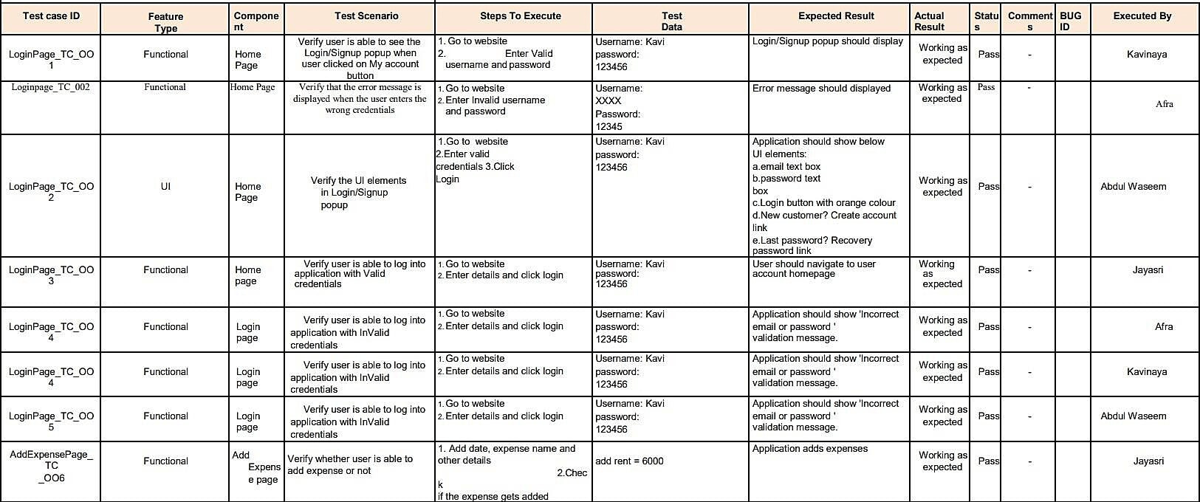

## 8.2 User Acceptance:

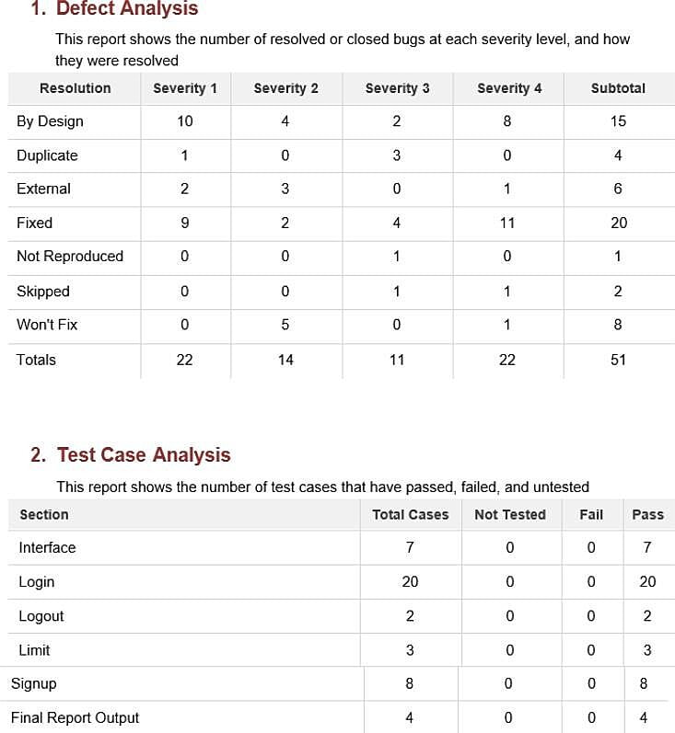

**ACCOUNT CREATING:**

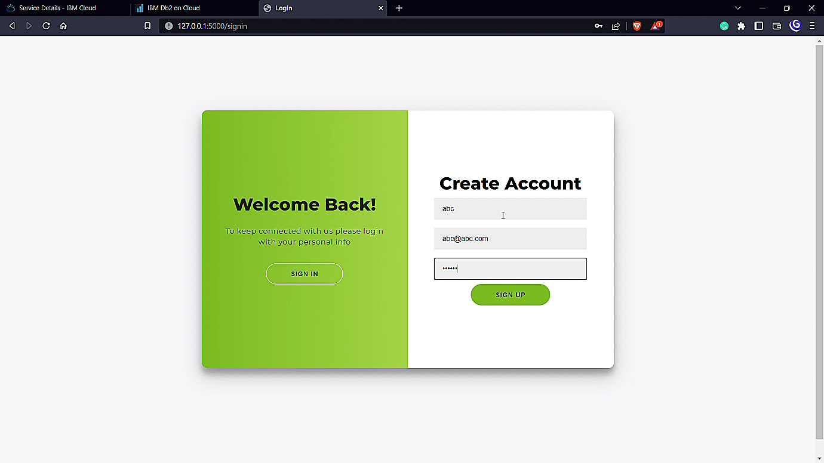

**LOGIN PAGE:**

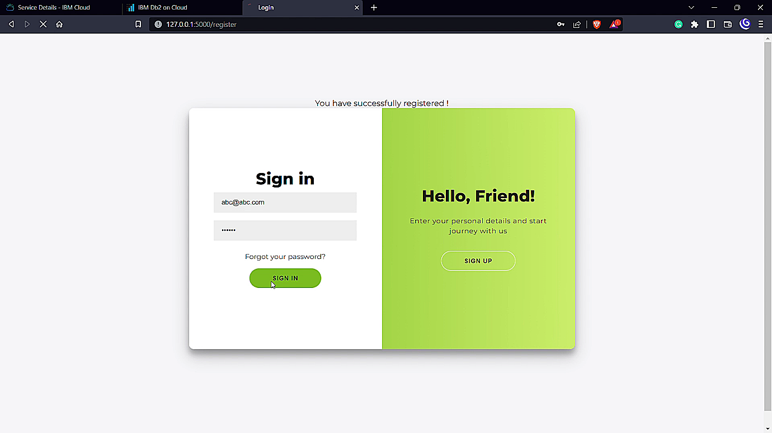

**ADD EXPENSE:**

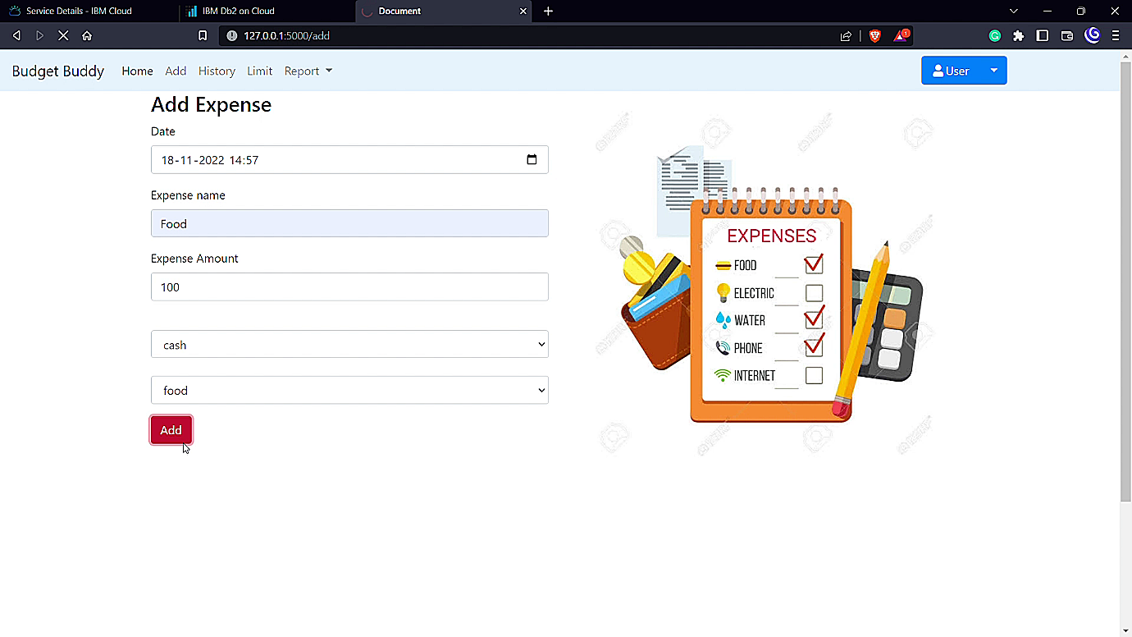

# 9. RESULTS

## 9.1 Performance Metrics :

* Tracking income and expenses: Monitoring the income and tracking all expenditures (through bank accounts, mobile wallets, and credit & debitcards).
* Transaction Receipts: Capture and organize yourpayment receipts to keep track of yourexpenditure.
* Organizing Taxes: Import your documents to the expense tracking app, and it will streamline your income and expenses under the appropriate taxcategories.
* Payments & Invoices: Accept and pay from credit cards, debitcards,netbanking,mobilewallets,andbanktransfers, and trackthe status of your invoices and bills in the mobile app itself. Also, the trackingapp sends remindersfor payments an d automatically matches the payments withinvoices.
* Reports: The expense tracking app generates and sends reports to give a detailed insight about profits, losses, budgets, income,balance sheets,etc.,
* Ecommerce integration: Integrateyour expense trackingapp wit h your eCommerce store and track your sales through payments received via multiple payment methods.
* Vendors and Contractors: Manage and track all the payments to the vendors and contractors added to the mobileapp.
* Access control: Increase your team productivity by providing access control to particular users through custom permissions.
* Track Projects:Determine project profitability by tracking laborcosts, payroll, expenses etc., of your ongoing project.
* Inventory tracking: An expense tracking app can do it all. Rightfrom tracking products or the cost of goods, sending alertnotifications when the product is running out of stock or the product is not selling, to purchaseorders.
* In-depth insights and analytics: Provides in-built tools to generate reports with easy-to- understand visuals and graphics to gain insights about the performance of yourbusiness.
* Recurrent Expenses: Rely on your budgeting app to track, streamline, and automate all the recurrent expenses and remindyou on a timelybasis.

An application can be a very powerful tool for businesses if once the app becomes a success. However, the success of an app is measured through numbers, metrics, and analytics. Developing an app takes quite a lot, so once you’ve dedicated much time, money, and effort to the process, it’s mandatory to measure mobile app performance.

# 10. ADVANTAGES AND DISADVANTAGES

## 10.1 Advantages:

* With proper tracking of your finances, you will not be able to determine unnecessary spending. This spending, if saved, can easily add up to quite a bit.
* In this day and age, when expenses are going through the roof, it has become crucial that you learn to make your money work for you so that you can create a nest egg for the future.
* Has various components of updating and viewing users’ expenditure
* User can track his expenses by choosing a day and using various filtering Options to study expenses
* Visualization using pie chart with percentage view shows graphical Representation.
* This approach effectively keeps away from the manual figuring for trying
* Not to ascertain the pay and cost each month.
* With a daily expense manager, you will be able to allocate money to different priorities and this will also help you cut down on unnecessary spending. As a result, you will be able to save and be able to keep worry at bay.
* A daily money tracker helps you budget your money so that you use it wisely. If you find that every month your expenses are more than what you earn, it is time to put your house in order and get a money manager app that keeps track of your money.

## 10.2 Disadvantages :

* Lack of visual analytics for expense data
* Lack of support for splitting group expenses
* Suitable for only Personal use.
* Errors are another common problem expense reports drafted with Excel. As is the case with all tasks performed manually and based on paper, it is extremely likely that business travelers who report expenses make involuntary mistakes: numbers entered wrongly, duplicated expenses or expenses relating to a previous settlement period, misapplication of the expense policy, etc.
* Frequent tracking of cash spending can allow one to catch and correct errors so that the budget plan is still able to be adhered to despite the mistake.

# 11. CONCLUSION

Tracking your expenses daily can save your amount, but it can also help you set financial goals for the future. If you know exactly where your amount is going every month, you can easily see where some cutbacks and compromises can be made.

# 12. FUTURE SCOPE

Although expense management practices and technology are making significant leaps, it is also true that there are many companies that still haven’t automated T&E processes. Ensuring the efficiency of your expense management processes doesn’t have to be extremely difficult, if you use the right tools.

This is a cloud-based solution that gives you total control over your personal expenses. You can provide role-based access for additional security.

# 13 . APPENDIX

**Demo Link:** <https://drive.google.com/file/d/1F3hB129q-ebNQHbuHXZtCXhAreW1vO-V/view?usp=share_link>

**Github Link :** <https://github.com/IBM-EPBL/IBM-Project-24256-1668681524>